DBMS LAB-10

NAME: NIKHIL RAJU MOHITE

SRN: PES1UG20CS667

SECTION: ‘5K’

1. Create train table and insert the data into the data base

Before insertion.

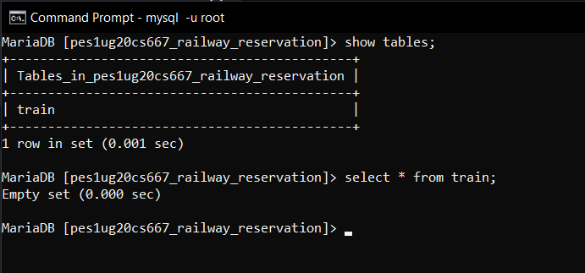

After insertion

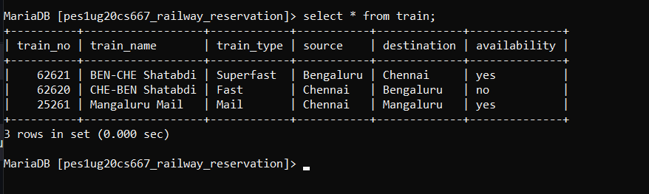

User Interface for the insertion of the data.

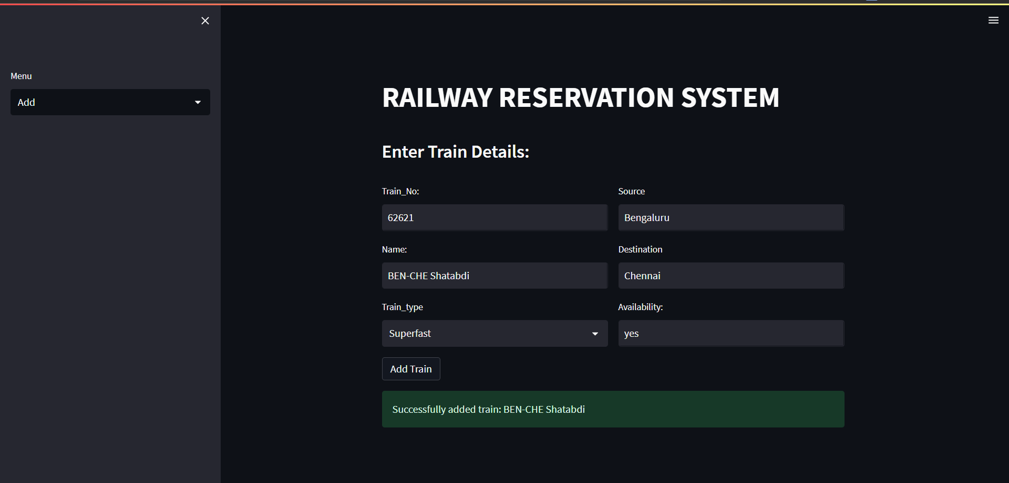

1. User interface showing data stored in the train table.

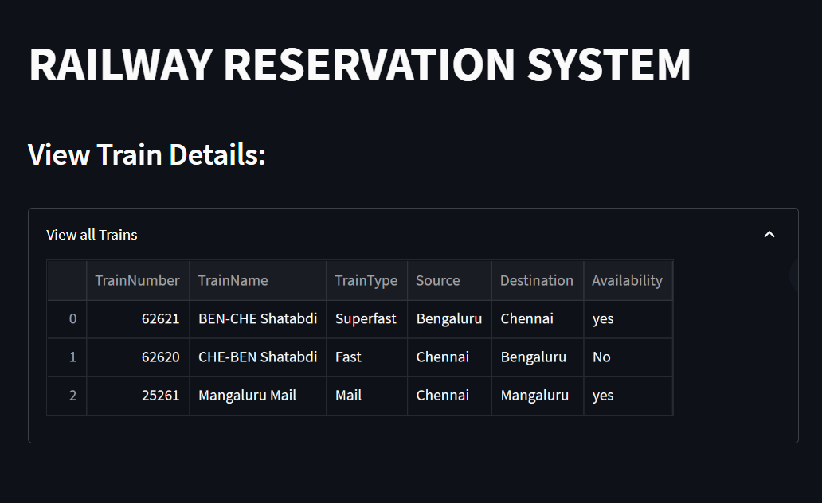

1. Updating the ‘availability’ of train 62620 to ‘yes’

Before

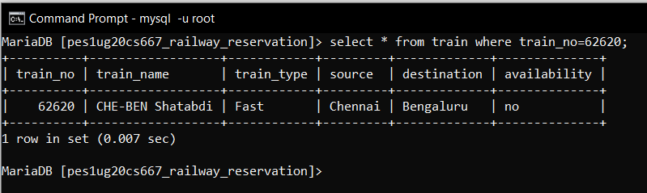

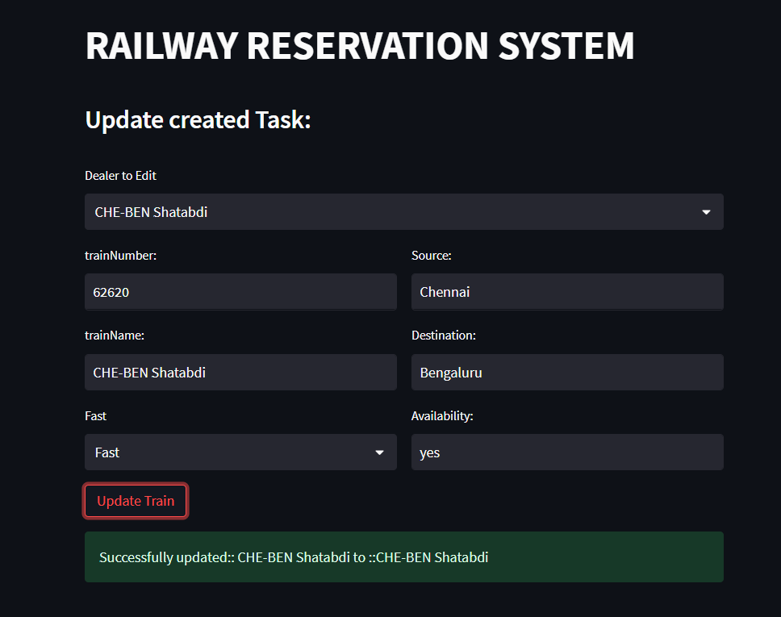

After update

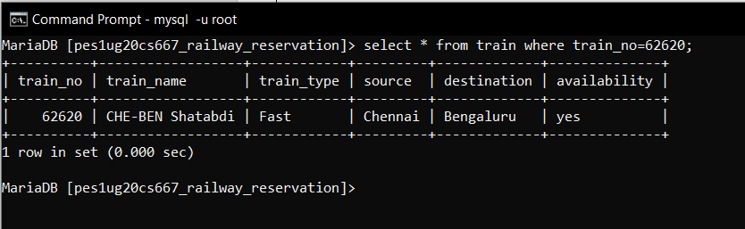

1. Deleting the train with train_no 25261

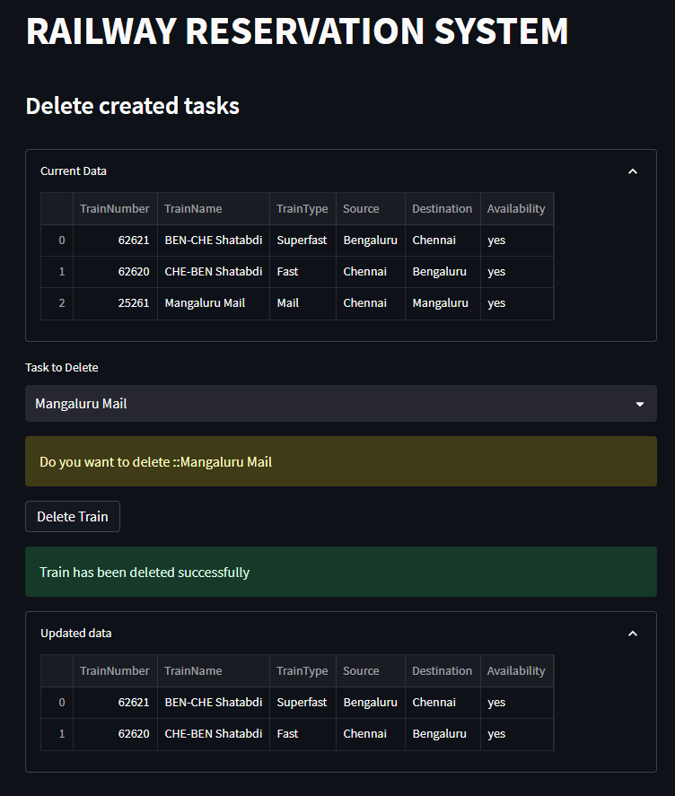

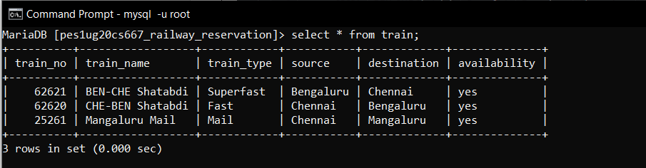

After delete

